(Approx. 893 words)

Windows Lab – Avoiding Web Ads and Cookies
by Penny Cano, a member of the Cajun Clickers Computer Club and Instructor for the Dumb & Dumber Workshops
November 2012 issue, Cajun Clickers Computer News
www.cccc.org
ccnewsletter (at) cox.net

Web advertisements often take up half of the real estate on a webpage. Supposedly, they entice the viewer into buying the products. In actuality, they help to financially support the host website. Cookies, on the other hand, are outwardly invisible. They are put on your computer by websites to identify you. There are good cookies and bad cookies. A secure website (bank, credit card, prescription order, etc.) requires a cookie
(good) on your computer to verify your identify. You cannot use the website unless you have their cookie. Public, retail, and other non-secure sites put tracking cookies (bad) on your computer to do things like determine which websites you frequent so they can
customize all those ads to what they believe are your interests. Personally, I like to avoid both intrusions. Here is how it can be done on the two browsers I use, Internet Explorer and Firefox.

Firefox is the easiest because there are add-ons you can download and install from . On the Firefox toolbar, select Tools/Add-ons/ Get Add-ons.Mozilla.org/
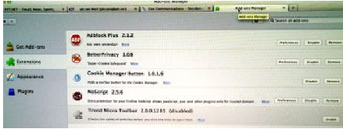

The two I find most useful are Adblock Plus and NoScript. Adblock Plus doesn't require setting changes other than to be sure the updates are automatic. NoScript installs easily, but it takes some personal interaction to make it work to your advantage. Many
ads on websites use Java script, Flash player, or other tools for the animation. NoScript gives you the option to choose which of these scripts you want to allow.

The two I find most useful are Adblock Plus and NoScript. Adblock Plus doesn't require setting changes other than to be sure the updates are automatic. NoScript installs easily, but it takes some personal interaction to make it work to your advantage. Many
ads on websites use Java script, Flash player, or other tools for the animation. NoScript gives you the option to choose which of these scripts you want to allow.

If an unknown script is attempting to execute, there is a yellow warning bar at the bottom of the Firefox window. Pressing the small “S” in the lower right corner of the status bar pops up a menu that allows you to trust (permit) scripts or block them. Usually I make “Untrusted” websites with “ads” (msads.net, adrevolver.com) or “click” (doubleclick.net), etc., in their name. If you make a mistake and block something
you need, you can always press the “S” button and go back and “Trust” the script.

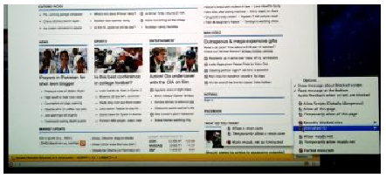

The third Add-on I find useful is BetterPrivacy which lets you choose which cookies to accept or deny. The same rule applies in choosing which website's cookies – deny “ads,” “track,” “click.” et c; accept “Discovercard,” “Chasebank,” and the like. Internet Explorer provides more of a challenge to block ads and cookies. I have not found an Add-on for IE that allows you to choose which scripts are allowed or blocks ads and tracking cookies on a wholesale basis. So it takes more effort on the user's part to accomplish the same thing. Somewhere in the IE settings there is a check box that says to tell websites you do not want to be tracked. But many of the websites do not honor this.

Also, you can use InPrivate Filtering (“Safety” button or under “Tools” on the menu) to block some sites. The most effective way I have found to block ads in IE is not in the IE settings. I use the Parental Control settings in my Virus/Internet Security suite. I use TrendMicro Titanium Internet Security. Under Parental Controls, I block the general category of “Web Advertisement,” but that doesn't get everything.

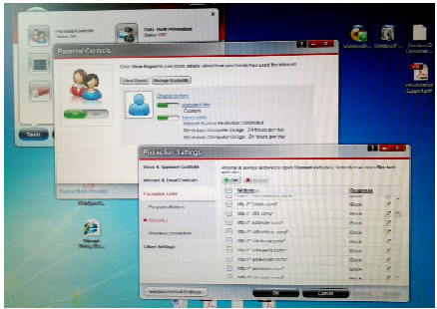

There is also a section of the Parental Controls that blocks individual websites. The same rule applies here as in Firefox – if the name includes “ads,” “click,” etc., it's usually a “Block.”

Cookie blocking can be done with IE settings under Tools/Internet Options on the menu or the Internet Options icon in the Control Panel. Initially, it is a pain in the neck, but worth it in the long run. On the Privacy tab chose the “Sites” button. If you already know the name of the website whose cookie is to be blocked, you can enter it and choose “Block.”

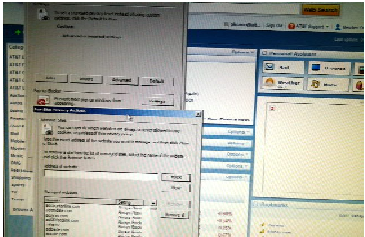

If the website doesn't work right without the cookie, you can always come back and remove the block. The next part can be annoying at first. On the Privacy tab choose
the “Advanced” button. Check the box to “Override automatic cookie handling” and mark “Prompt” for First-party and Third-party cookies. Now, each time a website tries to put a cookie on your computer, a Privacy Alert box will pop up. Hit the “Block” button.

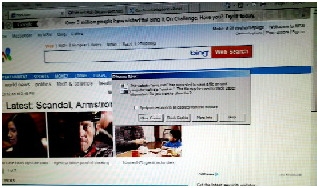

They are persistent and my try 20-40 times before the website loads. But if you can do everything you need to do while denying the cookies, the next time you visit the website and the box pops up, you can check the box that says “Apply my decision to all cookies from this website.” Then when you choose block, the website is added to the “Sites” list and you won't get the alert again. If you do this, after a while you will get few alerts and the cookies will automatically be blocked.

